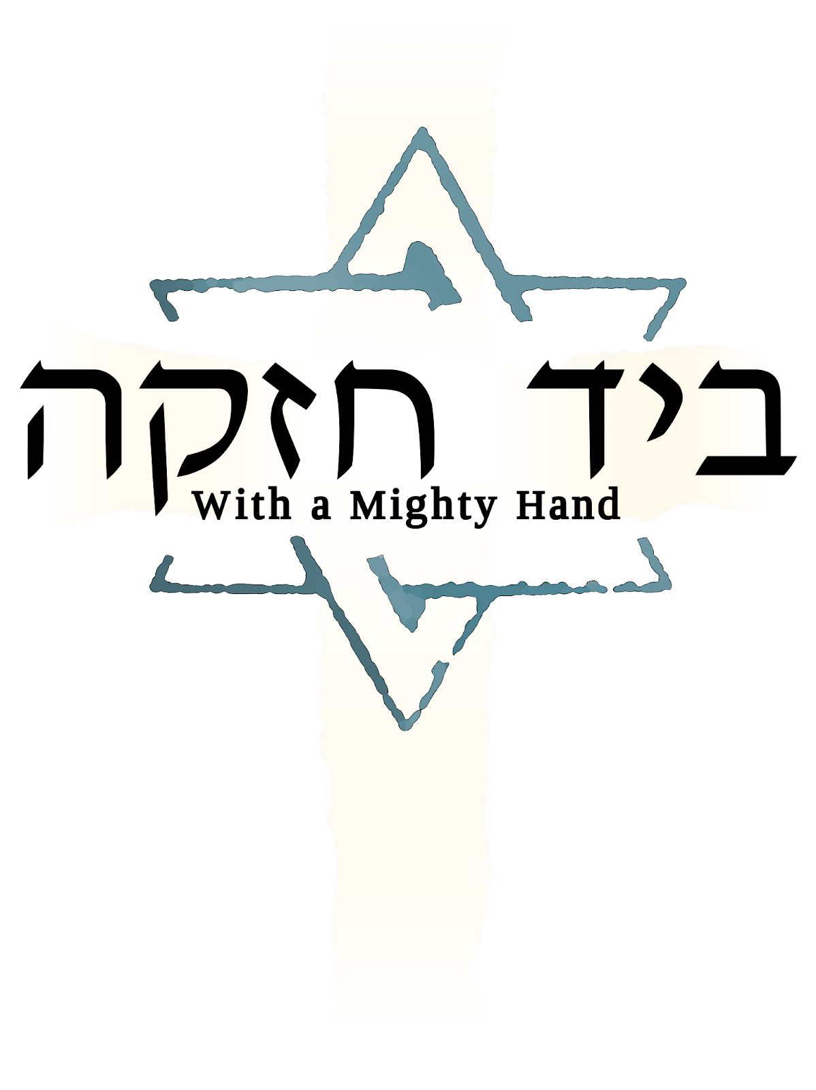

Then we cried out to the Lord God of our fathers, and the Lord heard our voice and looked on our affliction and our labor and our oppression. So, the Lord brought us out of Egypt with a mighty hand and with an outstretched arm, with great terror and with signs and wonders. He has brought us to this place and has given us this land, “a land flowing with milk and honey”
Deuteronomy 26:7-9

THE TABLE

On the Seder plate are set the following elements:

1. Matzah: unleavened bread. Three pieces are wrapped together in a cloth with three compartments.
2. Zeroah: the roasted shank bone of a lamb, a symbol of the paschal lamb.
3. Beitzah: an egg, hard-boiled and roasted, a traditional symbol of this spring season, and in this case also a symbol of our new life through Yeshua.
4. Maror: bitter herbs, to symbolize the bitterness of slavery in Egypt.
5. Charoset: a sweet mixture of fruit, nuts, cinnamon and wine. This symbolizes the mortar and clay with which the children of Israel labored.
6. Karpas: parsley or celery, to be dipped in salt water and eaten.
7. Salt Water: used for dipping the karpas.

We have a special place set for Elijah the prophet, who is said will come again on a Seder night like tonight to announce the Messiah’s coming.

The Four Cups

We will drink four cups of wine this evening to symbolize the four divine promises to free us from captivity:

God's Four Promises (Exodus 6:6-7)
1st cup: Sanctification
Therefore, say to the children of Israel: ‘I am the Lord, and I will bring you out from under the burdens of the Egyptians.'
2nd cup: Deliverance/Thanksgiving
‘I will rescue you from their slavery.’
3rd cup: Redemption
‘I will redeem you with an outstretched arm and with Mighty acts of judgment.’
4th cup: Completion/Hallel (praise)
‘I will take you as my own people, and I will be your God. Then you will know that I am the Lord your God, who brought you out from under the burdens of the Egyptians.’

LIGHTING THE CANDLES

[candles are lit]

Daughter of Zion:

Barukh atah Adonai Eloheinu Melekh ha’olam,
asher kid’shanu b’mitzvotav v’tzivanu l’hiyot or l’goyim
v’natan lanu Yeshua Meshicheinu Ha'or Le'olam

Blessed are You, O Lord our God, King of the universe,
Who has sanctified us by His commandments,
and commanded us to be a light to the nations
and gave us Yeshua our Messiah, the Light of the World

Barukh atah Adonai Eloheinu Melekh ha'olam,
asher kid’shanu bidevaro uvishmo anakhnu madlikim,
haneyrot shel yom tov.

Blessed are You, O Lord our God, King of the universe,
Who has sanctified us by His Word, and in Whose name we light
the Festival Lights.

Barukh atah Adonai Eloheinu Melekh ha’olam,
shehecheyanu vekiymanu vehigiyanu lazman hazeh

Blessed are You, O Lord our God, King of the universe,
who has granted us life, sustained us,
and enabled us to reach this occasion.

KADESH
THE CUP OF SANCTIFICATION

The Lord spoke to Moshe, “Go in to Pharaoh, and tell him, ‘This is what The Lord says, “Let my people go, that they may serve me.”
Exodus 8:1

As we drink this first cup we remember that we are sanctified by our relationship with our God through Yeshua Hameshiach.

[pour the wine]

We will now say the blessing:

All:

Barukh atah Adonai Eloheinu Melekh ha’olam,
borei p'ri hagafen.

Blessed are You, O Lord our God, King of the universe,
who creates the fruit of the vine.

URCHATZ

At the entrance to the Temple in Jerusalem there stood a great bronze laver, a basin in which the priests cleansed themselves before entering into the presence of God. Before we dip our first vegetables, we will wash our hands in accordance with this ancient practice. Let us now recall the example of our Messiah Yeshua when, at his own Passover Seder with the disciples, he laid aside his garments and girded himself with a towel:

He poured water into a basin and began to wash the disciples’ feet, and to wipe them with the towel which was wrapped around him.... After he had washed their feet, taken back his clothes and returned to the table, he said to them, “Do you understand what I have done for you? You call me Rabbi and Lord and you are right, because I am. Now if I, your Lord and Rabbi, have washed your feet, you should also wash each other's feet.”
John 13

[Now wash each other’s hands]

KARPAS

The salt water before us represents the tears of affliction. As we dip our vegetables, let us take a moment to remember the children of Israel, who toiled under the cruel taskmasters of pharaoh. May we never forget that, even in the midst of God's provision, life is sometimes immersed in tears.

[now pass parsley and salt water, but do not eat]

We will now say the blessing:

All:

Barukh atah Adonai Eloheinu Melekh ha’olam,
borey p'ree ha'adamah.

Blessed are You, O Lord our God, King of the universe,
Who creates the fruit of the earth.

[now eat]

INVITATION

Leader:

[Hold up the middle of the three matzot]

This is the bread of affliction that our ancestors ate in the land of Egypt. Let all who are hungry come and eat. Let all who are needy come and celebrate Passover. Now we are here; next year in the land of Israel. Now we are slaves; next year we will be free. Now, we are in this world; next year, may we be in the Olam Haba.

YACHATZ

This is the bread of affliction and deprivation, which our forefathers ate in the land of their bondage. And yet, it is life and sustenance. It represents the hope and the promise of salvation.

[break the middle piece of matzah, and wrap and hide the larger piece]

MAGGID

On that day tell your son, ‘I do this because of what the Lord did for me when I came out of Egypt.’ This observance will be for you like a sign on your hand and a reminder on your forehead that the law of the Lord is to be on your lips. For the Lord brought you out of Egypt with His mighty hand. You must keep this ordinance at the appointed time year after year.
Exodus 13:8-10

And when your children say to you, ‘What do you mean by this service?’ you shall say, ‘It is the sacrifice of the Lord’s Passover, for he passed over the houses of the people of Israel in Egypt, when he struck the Egyptians but spared our houses.’ So the people bowed their heads and worshiped.
Exodus 12:26-27

THE FOUR QUESTIONS

Child:

Ma nishtanah halailah hazeh mikol haleilot?

Sheb’khol haleilot anu okhlin hametz umatzah;
halailah hazeh, kuloh matzah.

Sheb’khol haleilot anu okhlin sh’ar y’rakot;
halailah hazeh, maror.

Sheb’khol haleilot ein anu matbilin afilu pa’am echat;
halailah hazeh, shtei f’amim.

Sheb’khol haleilot anu okhlin bein yoshvin uvein m’subin;
halailah hazeh, kulanu m’subin.

Why is this night different from all other nights?

On all other nights we eat leavened bread or matzah.
On this night why do we eat only matzah?

On all other nights we eat all kinds of vegetables.
On this night why do we eat bitter herbs?

On all other nights we do not dip our vegetables even once.
On this night why do we dip them twice?

On all other nights we eat our meals sitting or relaxing.
On this night why do we eat only relaxing?

MOTZI MATZAH

Leader:

On all other nights we eat leavened bread or matzah.
On this night why do we eat only matzah?

The children of Israel fled Egypt in great haste, and there was no time to allow their dough to rise. Let us now share a piece of matzah.

[distribute matzah, but do not eat]

We will now say the blessing:

All:

Barukh atah Adonai Eloheinu Melekh ha’olam,
hamotzi lechem min ha'aretz.

Blessed are You, O Lord our God, King of the universe,
Who brings Forth Bread from the earth.

[now eat]

Leader:

Barukh atah Adonai Eloheinu Melekh ha’olam,
asher kid’shanu b’mitzvotav v’tzivanu al achilat matzah.

Blessed are You, O Lord our God, King of the universe,
Who has sanctified us by His commandments, and commanded us to eat matzah.

MAROR

Leader:

On all other nights we eat any vegetable.
On this night why do we eat only bitter herbs?

Tonight, we eat bitter herbs to remind us of our bondage in Egypt. Even though our captivity was harsh, the captivity by our own sin is no less so. As we eat, let us recall the years of bondage, both theirs and our own.

[distribute matzah and horseradish]

All:

Barukh atah Adonai Eloheinu Melekh ha’olam,
asher kid’shanu b’mitzvotav v’tzivanu al akhilat maror.

Blessed are You, O Lord our God, King of the universe,
Who has sanctified us by His Word, and commanded us to eat bitter herbs.

[now eat]

SECOND DIP

Leader:

On all other nights we do not dip our vegetables even once.
On this night why do we dip them twice?

Tonight, we dip our vegetables twice because our exile in Egypt involved two dippings: First was Joseph’s coat, dipped in blood. The second was hyssop dipped in blood and applied to the doorposts. The first was the catalyst that lead to our eventual captivity in Egypt the second, resulted in our freedom.

Now we dip together in that freedom.

[distribute the parsley and salt water, but do not eat]

All:

Barukh atah Adonai Eloheinu Melekh ha’olam,
borei p'ri ha'adamah.

Blessed are You, O Lord our God, King of the universe,
Who creates the fruit of the earth.

[now eat]
KORECH

Our labor in Egypt involved bricks and mortar. This charoset, made with fruit and nuts, spices and wine, serves as a symbol for the mortar and clay with which our ancestors did their grueling labor. Let us once more take a bit of horseradish on a piece of matzah. However, this time we will eat it with sweet charoset to remind us that all affliction can be sweetened by our hope in God.

[distribute the matzah, horseradish, and charoset]
[eat without a blessing]

All:

We were slaves to Pharaoh in Egypt, but the Lord our God brought us out from there with a Mighty hand and an outstretched arm.

Leader:

On all other nights we eat our meals sitting or relaxing.
On this night why do we eat only relaxing?

During our first Passover, we ate in haste with our “loins girded, sandals on our feet, and our staff in our hands.” Today, we eat relaxing because we are a free people and the need for urgency is gone.

THE TELLING

Reader 1:
God chose for Himself a people and vowed to make them as numerous as the sands of the desert and the stars in the sky, to bring them into their own land and to make them a mighty people. Even when they were slaves in Egypt God blessed them and caused them to increase. When Pharaoh saw this foreign race prospering in his land, his heart grew troubled and he said to his people, “Look, the Israelites have become far too numerous for us. Let us deal harshly with them, so that they may not increase.” They subjected them to forced labor, but the more they were oppressed, the more they increased.

Reader 2:
So the king of Egypt commanded the Hebrew midwives to kill all of the baby boys they delivered among the women of the Israelites; but the midwives feared God and allowed the boys to live. Pharaoh saw that the people continued to increase, and he ordered all male children born to them to be cast into the river Nile and drowned. So, when Moses was born, his mother hid him. After three months she could hide him no longer. Getting a wicker basket for him, she caulked it with pitch and placed her child inside before hiding it among the reeds by the banks of the Nile. Soon after, the infant was found by Pharaoh’s daughter, and it was she who gave him the name Moses, meaning “drawn from the water.”

Reader 3:
When Moses grew older, Pharaoh's daughter adopted him as her son and took him to live in Pharaoh's palace, and he did not know of the suffering of his people. One day he left the palace and walked among his kinfolk and witnessed their labors. It was then he witnessed an Egyptian beating a Hebrew slave. He was filled with rage and slew the overseer and hid his body in the sand. When Pharaoh learned of the matter, he sought to kill Moses, but he fled from Pharaoh and settled in the land of Midian.

Reader 4:
The people cried out to God and He took pity on their affliction. He remembered His covenant with their fathers. God spoke to Moses from a bush that burned with fire but was not consumed. “I am the God of your fathers, the God of Abraham, the God of Isaac, and the God of Jacob. I have heard the groanings of my people and I am mindful of their sufferings. I have come down to rescue them from the Egyptians and to bring them out of that land into a good and spacious land, a land flowing with milk and honey. I will send you to Pharaoh and you shall free my people, the Israelites, from Egypt.”

CUP OF DELIVERANCE

We fill our cups a second time. This is the Cup of Plagues, also known as the Cup of Wrath. We will not drink from this cup. Instead, we will leave it for later when it will become the Cup of Deliverance.

[fill cups]

Pharaoh's heart was hardened and he would not free God's people.

I know that the king of Egypt will let you go only because of a greater might. So I will stretch out my hand and smite Egypt with various wonders which I will work upon them; after that he shall let you go.
Exodus 3:19-20

A full cup is, appropriately, a symbol of joy. Even still, we are moved by the heavy price that was paid to purchase our redemption and freedom. To remember this sacrifice we will recite the ten plagues, three times each. With each recitation, dip a finger into your cup and allow a drop of wine to fall onto your plate three times.

INSERT HEBREW

All:

Blood, Blood, Blood

Frogs, Frogs, Frogs

Lice, Lice, Lice

Flies, Flies, Flies

Cattle Disease, Cattle Disease, Cattle Disease

Boils, Boils, Boils

Hail, Hail, Hail

Locusts, Locusts, Locusts

Darkness, Darkness, Darkness

Death of the Firstborn, Death of the Firstborn, Death of the Firstborn

[do not drink yet]

Leader:
[Lifting the shank bone]

This shank bone represents the lamb that was slain. Its blood was placed upon the doorposts of the homes of the children of Israel, signifying their salvation from the death that walked among them.

Reader 1:
Speak to the whole community of Israel and say that on the tenth of this month each of them shall take a lamb to a family, a lamb to a household. But if the household is too small for a lamb, let him share one with a neighbor who dwells nearby...
Exodus 12:3-4

Reader 2:
Your lamb shall be without blemish, a yearling male... You shall keep watch over it until the fourteenth day of this month; and the whole assembly of the congregation Israel shall slaughter it at twilight.
Exodus 12:5-6

Reader 3:
They shall take some of the blood and put it on the two doorposts and the lintel of the houses in which they are to eat it. They shall eat the flesh that same night; they shall eat it roasted over the fire, with unleavened bread and bitter herbs.
Exodus 12:7-8

Reader 4:
And the blood on the houses where you are staying shall be a sign for you: when I see the blood, I will pass over you, so that no plague will destroy you when I strike the land of Egypt.
Exodus 12:13

Leader:

The blood of the lamb was the symbol of God's protection, but it was God Himself who provided redemption.

All:

We cried to the Lord, the God of our fathers, and the Lord heard our plea and saw our plight, our misery, and our oppression. The Lord freed us from Egypt by a mighty hand, by an outstretched arm and awesome power, and by signs and wonders.
Deuteronomy 26:7-8

DAYENU

Leader:

The goodness of God to us is beyond our understanding. As we recall each of His acts of mercy and kindness, we declare “Dayenu” (It would have been sufficient.)

Leader: If the Lord had brought us out of Egypt and not divided the sea for us,
All: Dayenu!
If He had divided the sea for us and not sustained us through the wilderness forty years,
All: Dayenu!
If He had sustained us through the wilderness forty years and not fed us with manna,
All: Dayenu!
If He had fed us with manna and not given us the Sabbath,
All: Dayenu!
If He had given us the Sabbath and not given us the Torah,
All: Dayenu!
If He had given us the Torah and not brought us into the Land of Israel,
All: Dayenu!
If He had brought us into the Land of Israel and not built for us the Temple.
All: Dayenu!
If He had built for us the Temple, but not come to dwell among us.
All: Dayenu!

Leader:
But, He brought us out of Egypt and executed judgment against our enemies. He destroyed their idols and slew their first-born. He gave us their possessions and divided the sea for us. He drowned our oppressors in it and sustained us through the wilderness forty years. He fed us with manna and gave us the Sabbath. He gave us His Torah, and brought us into the Land of Israel, He built for us the Temple, and came to dwell among us.

All:

Blessed are you, O Lord our God, for all your blessings and tender mercies toward us. You have given us abundant life on Earth and eternal life in Heaven.

Now we will lift this Cup of Deliverance together.

All:

Barukh atah Adonai Eloheinu Melekh ha’olam,
borei p'ri hagafen.

Blessed are You, O Lord our God, King of the universe,
Who creates the fruit of the vine.

SHULCHAN ORECH

Now we will say a blessing over our meal.

All:

Barukh atah Adonai Eloheinu Melekh ha’olam,
borei minei mezonot.

Blessed are You, O Lord our God, King of the universe,
Who creates various kinds of sustenance.

Barukh atah Adonai Eloheinu Melekh ha’olam,
Shehakol nih’yah bidvaro

Blessed are You, O Lord our God, King of the universe,
Who by His Word brings about all things.

[eat supper now]

BAREKH

Leader: Now that we have eaten, let all who are thankful say grace.

All: May the name of the Lord be blessed forever.

Leader: Let us bless Him, the Lord, whose food we have eaten.

All: Blessed be He, whose food we have eaten and in whose goodness we live.

Leader:

Blessed are You, O Lord our God, King of the universe, Creator of all living beings and their needs, for all the things you created to sustain the soul of every life. Blessed be He, who is the life of the world.

All: Blessed be He, and blessed be His name. Amen

TZAFUN
THE AFIKOMAN

Earlier tonight, a piece of matzah was hidden. It’s time now for it to be returned.

As we eat this matzah, allow the taste to linger in your mouth and remember what Yeshua said to his disciples at his last Seder.

He took bread, and when he had given thanks, he broke it and gave it to them, saying, ‘This is my body which is given for you; do this in memory of me.”
Luke 22:19

All:

Barukh atah Adonai Eloheinu Melekh ha’olam,
hamotzi lechem min ha'aretz.

Blessed are You, O Lord our God, King of the universe,
Who Brings Forth Bread from the earth.

[now eat]

THE CUP OF REDEMPTION

Let us fill our cups again for the third time. This is the Cup of Redemption. By tradition, it represents the blood of the Passover (Paschal) lamb.

[fill cups]

In the same way, after the Passover meal Yeshua took the cup, saying, “This cup is the New Covenant in My blood, which is poured out for you.”
Luke 22:20

All:

Barukh atah Adonai Eloheinu Melekh ha’olam,
borei p'ri hagafen.

Blessed are You, O Lord our God, King of the universe,
Who creates the fruit of the vine.

[drink]

The cup of blessing which we bless, is it not a sharing of the blood of the Messiah? The bread which we break, is it not a sharing of the body of the Messiah? Because there is one bread, we the many are one body, for we all partake from the one bread.
1 Corinthians 10:16-17
ELIYAHU HANAVI

Every year we set a place for Elijah. It is said that he will return one Seder evening to herald the return of the Messiah.

Look, I will send to you Eliyahu the prophet before the coming of the great and terrible Day of the Lord. He will turn the hearts of the fathers to the children and the hearts of the children to their fathers; otherwise I will come and strike the land with complete destruction.
Malachi 3:23-24

Now we will go open the door and see if he has come.

[go open door]

Eliyahu the prophet, Eliyahu the Tishbite, Eliyahu the Giladite, may he soon come to us, with the Messiah son of David.

Yeshua spoke of John, saying, “Indeed, if you are willing to accept it, he is Eliyahu, whose coming was predicted.”

HALLEL
CUP OF PRAISE

We fill our cup for the fourth and final time. It is of this cup that our Lord and Savior, Yeshua Ha'Mashiach, said, “I tell you, I will not drink of this fruit of the vine from now on until that day when I drink it anew with you in my Father's Kingdom.”

[fill cups]

All:

Barukh atah Adonai Eloheinu Melekh ha’olam,
borei p'ri hagafen.

Blessed are You, O Lord our God, King of the universe,
Who creates the fruit of the vine.

[drink]

All:

Lashanah Habah Bi Yerushalayim!

Next year in Jerusalem!

[this concludes the Seder]

God's Word is our great heritage
And shall be ours forever;
To spread its light from age to age
Shall be our chief endeavor.
Through life it guides our way,
In death it is our stay.
Lord, grant, while worlds endure,
We keep its teachings pure
Throughout all generations.

-Nikolai F. S. Grundtvig

With a Mighty Hand, Haggadah for Passover Seder (2022) Daniel Morrow (Ed.)
Adapted from traditional sources and written with love for the sake of our beautiful heritage.

Additional Resources:
Rabbi Nathan Goldberg
Rabbi Alfred J. Kolatch
Martha Zimmerman
Pam Staley
Greg Killian
Eddie Chumney
John F. Phelps
Jerry Sumner
Beth El Shaddai

